Course Repeat Changes in CIM

Overview
All undergraduate NR courses need to be updated to N3 to comply with University Policy AP.1.3.4 Repeating a Course. This enforces the policy that there is a limit of three graded attempts for all courses. Units will need to review the spreadsheet provided and update their existing NR courses to N3.
!!All changes MUST be submitted via CIM by February 23rd, 2019!!

Instructions
- Open a web browser and go to http://workingcatalog.gmu.edu/courseadmin
- Login using Mason credentials.
- Search for the course or list of courses
  - You can select a specific course ie. ACCT 204, or a series of courses like ANTH 3* to list all 300 level ANTH courses.
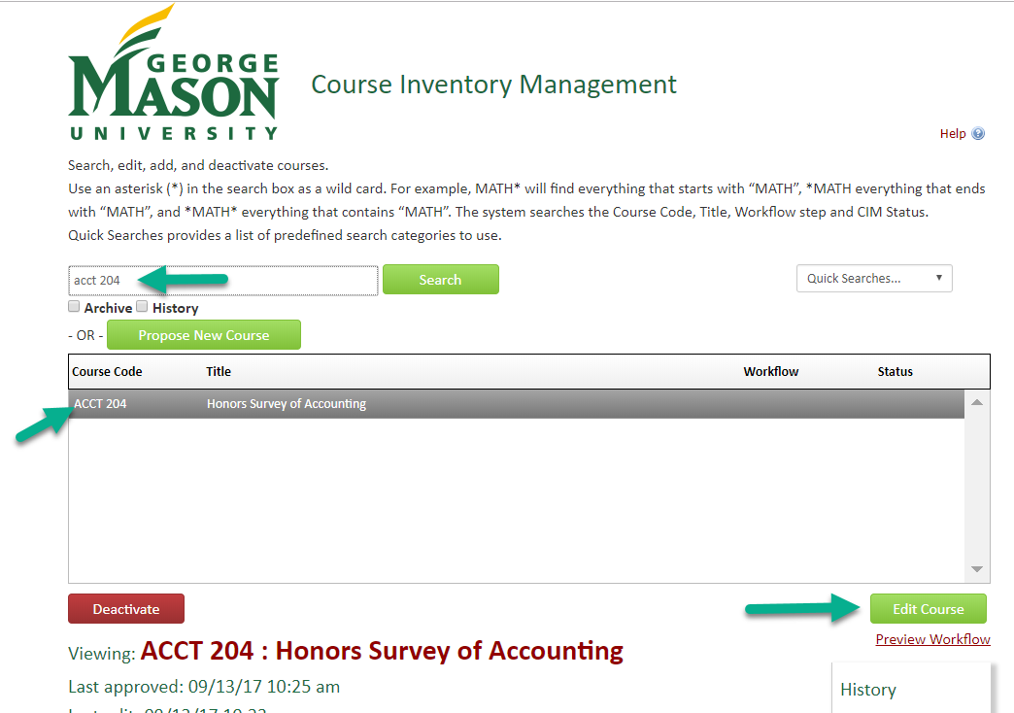
- Click Edit Course

- Changing the repeat status is a simple change so you can leave the modification type as “Simple”
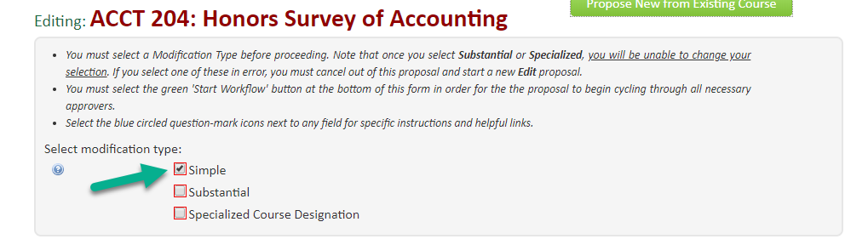
- Scroll down until you see the Repeatable label. Click the dropdown and select “May only be taken once for credit, limited to 3 attempts (N3) from the list of options.
- A box will then appear asking for the max allowable credits:
  - For courses limited to 3 attempts: enter the amount which is equal to the credits of the course * 3. (e.g. for a 3 credit course, 3*3=9; enter 9 credits)
  - If a course is variable credits, use the max credits and multiply by 3.
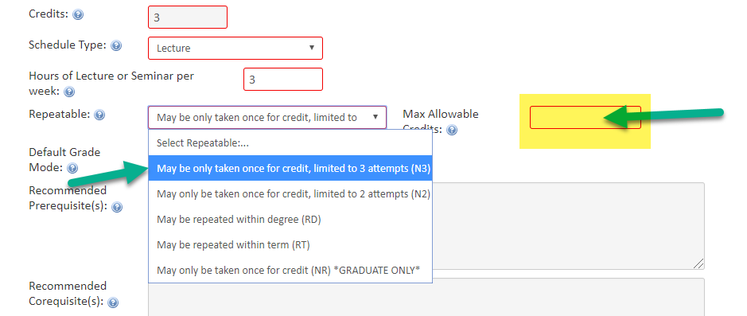

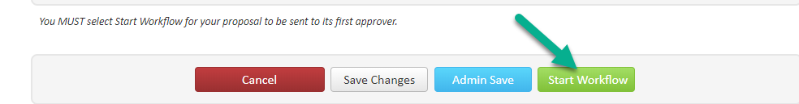
- Scroll to the bottom of the page and click Start Workflow.
- The course will then go through workflow and end with the Registrar’s Office where the course will be updated in banner.

Questions?
Contact the Office of the University Registrar at catalog@gmu.edu.

