HOW TO: Run a Role Report for CIM Workflows
- Log in at https://workingcatalog.gmu.edu/courseleaf/. The recommended browser for reporting via CourseLeaf is Firefox.
- Scroll down to the Reports menu.
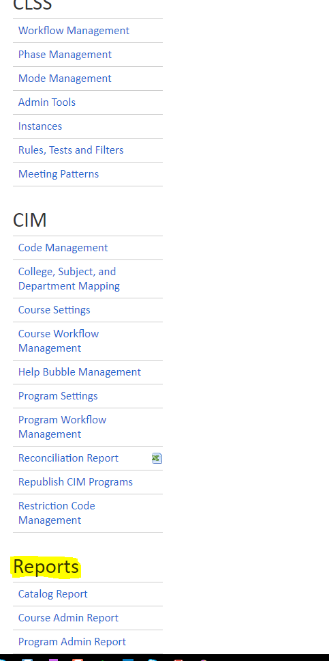

- Click on either Course Admin Report or Program Admin Report (it doesn’t matter which one you choose, you will navigate to the same role report).
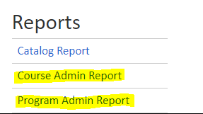
- Click Stock
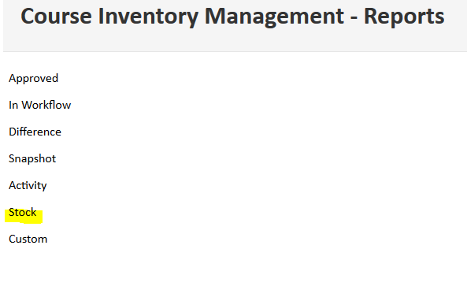
- Select Role Members and click the green Run Report button.
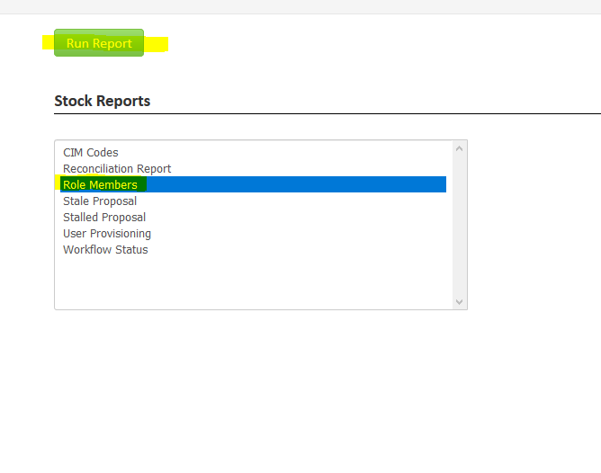
- The report will populate in the screen. You can filter the report and sort alphabetically by field from here, by clicking the Filter button, or clicking on the headers.

- You can also Export to a Word or Excel file by clicking the Export button.

- We recommend exporting the report and filtering it down to your unit’s specific roles.
- The “DUS” roles are for academic scheduling in CLSS, please disregard those as they are managed by the Academic Scheduling team and are not relevant for CIM management.
- Please disregard the “Banner” and all “Registrar” roles as those are accessed by our office only for administrative purposes.
- Multiple users are often listed under the same role. The e-mail notification settings for a role can be customized to include e-mail notifications for all, some, or a single user assigned to a role. If you would like to check on the e-mail settings for one of your roles, just contact us at catalog@gmu.edu so that we can assist you.

